MODULE-03

INDIVIDUAL TASK-03

Understanding Big Data Around Me

Abstract
Big Data is the collection of extremely large and complex datasets generated continuously from digital activities, devices, and systems. It has transformed the way we live, work, and interact, providing insights that were previously impossible to obtain.
Big Data is all around us—social media activity, online shopping behavior, financial transactions, healthcare monitoring, transportation systems, and smart devices all generate vast amounts of data every second.
Understanding Big Data helps individuals and organizations make informed decisions, optimize processes, and drive innovation. This document explores the concept, sources, types, applications, benefits, challenges, and future trends of Big Data, emphasizing its presence and impact in our daily lives.

1. Introduction
Big Data refers to datasets that are too large, fast, or complex to be processed using traditional data management tools. In today’s digital era, almost every action we take—posting on social media, shopping online, using a smart device—creates data. This data, when analyzed, can reveal patterns, trends, and insights that help individuals, businesses, and governments make better decisions.
Key Characteristics of Big Data (5 Vs):
- Volume: Huge amounts of data generated every second.
- Velocity: Data is created and processed in real-time or near real-time.
- Variety: Includes structured, semi-structured, and unstructured data.
- Veracity: Accuracy and reliability of data.
- Value: Data is meaningful only if it provides actionable insights.
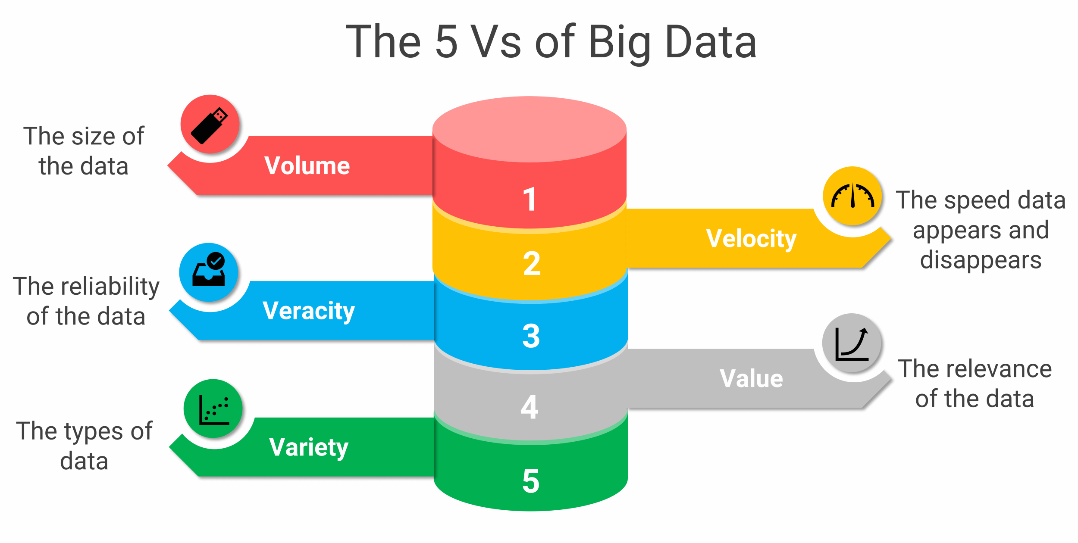

2. Sources of Big Data Around Me
Big Data is all around us, generated by devices and services we use daily:
- Social Media: Facebook, Instagram, and TikTok produce enormous data from posts, likes, comments, and shares.
- E-Commerce: Online platforms like Amazon track searches, clicks, and purchases to understand consumer behavior.
- Healthcare: Hospitals and wearable devices track health data, such as heart rate, steps, and medical history.
- Finance: Banks and payment apps monitor transactions to detect fraud and offer personalized services.
- IoT Devices: Smart home devices, fitness trackers, and connected cars constantly generate real-time data.
- Transportation: GPS-based apps like Google Maps analyze traffic patterns and travel times.
- Government Services: Census surveys, public transportation systems, and smart city sensors produce data for planning and optimization.
Observation: Even if we do not see it, Big Data is generated constantly and shapes decisions in real-time.

3. Types of Big Data
- Structured Data: Organized in rows and columns (e.g., spreadsheets, relational databases).
- Unstructured Data: Raw data such as videos, images, social media posts, and emails.
- Semi-Structured Data: Partially organized data like JSON files, XML, and logs from IoT devices.
Example:
- Structured: Sales data in a store’s database.
- Unstructured: Customer reviews on social media.
- Semi-Structured: Logs from smart home devices.

4. Big Data Technologies
Processing Big Data requires specialized tools and technologies:

Storage Solutions
- Hadoop Distributed File System (HDFS): Stores massive datasets across multiple servers.
- NoSQL Databases: MongoDB and Cassandra handle unstructured data.
- Cloud Storage: AWS, Google Cloud, and Azure provide scalable storage.

Processing Frameworks
- Apache Spark: Fast in-memory processing.
- Apache Flink: Real-time data stream processing.
- MapReduce: Batch processing large datasets.

Analysis & Visualization
- Machine Learning & AI: Predict patterns, make predictions, and provide recommendations.
- Visualization Tools: Tableau, Power BI, and Matplotlib turn data into interpretable insights.

5. Applications of Big Data Around Me

Healthcare
- Wearable devices monitor vitals in real-time.
- Hospitals use predictive analytics to prevent diseases.

Retail & E-Commerce
- Personalized recommendations based on past purchases.
- Inventory optimization using sales data trends.

Finance
- Fraud detection by analyzing transaction patterns.
- Credit scoring using historical financial data.

Transportation
- Traffic optimization using GPS data.
- Ride-sharing apps dynamically match drivers and passengers.

Entertainment
- Streaming platforms like Netflix or Spotify suggest content based on viewing/listening habits.

6. Benefits of Big Data
- Better Decision-Making: Data-driven insights reduce guesswork.
- Efficiency: Optimizes operations and resources.
- Innovation: Helps create new products and services.
- Personalization: Improves customer experience.
- Predictive Analytics: Forecasts future trends and risks.

7. Challenges of Big Data
- Data Privacy & Security: Risk of misuse of personal information.
- Data Quality: Poor quality data leads to wrong conclusions.
- Integration Complexity: Difficult to combine multiple sources of data.
- Infrastructure Costs: Storing and processing Big Data is expensive.
- Skill Gap: Requires specialized knowledge in analytics and AI.

8. Case Studies Around Me
- Healthcare: Hospitals using predictive analytics reduce patient readmission.
- Retail: Amazon optimizes inventory and personalized recommendations using customer data.
- Transportation: Uber uses real-time GPS and traffic data for faster and more efficient rides.

9. Tools for Big Data Analytics
- Hadoop Ecosystem: HDFS, Hive, Pig.
- Data Warehousing: Amazon Redshift, Google BigQuery.
- Machine Learning Platforms: TensorFlow, PyTorch, Scikit-learn.
- Visualization Tools: Tableau, Power BI, D3.js.
- Real-Time Analytics: Apache Kafka, Apache Flink.

10. Future of Big Data Around Me
- AI Integration: Automates analysis and predictions.
- Real-Time Analytics: Decisions are made instantly.
- Edge Computing: Processes data closer to devices for faster response.
- Data Democratization: Access to Big Data insights will expand beyond large corporations.
- Predictive & Prescriptive Analytics: Helps anticipate trends and make actionable decisions.

11. Big Data and Daily Life: Practical Examples Around Me
Big Data is not abstract—it affects our daily lives in ways we often don’t notice:
- Smartphones: Every app collects usage data, locations, and preferences to suggest apps, content, or ads.
- Social Media Feeds: Algorithms curate your feed using billions of data points from users worldwide.
- Streaming Services: Platforms like Netflix or YouTube use Big Data to recommend videos you are likely to watch next.
- Weather Forecasting: Satellites, sensors, and historical weather data are analyzed to predict rainfall, storms, and climate patterns.
- Fitness Trackers & Wearables: Data about steps, heart rate, and sleep patterns help people track health and improve lifestyles.
Observation: Big Data surrounds us daily, creating a “digital footprint” that powers insights, recommendations, and predictions.

12. Big Data Analytics in Education
- Schools and universities analyze student performance data to identify learning gaps.
- Online learning platforms use engagement metrics to improve course content.
- Predictive analytics helps in student retention and success by identifying at-risk learners early.
Example: Coursera or Khan Academy uses data on quiz performance, time spent on videos, and engagement to personalize learning experiences.

Conclusion:
Big Data is no longer a concept—it is a daily presence around us, impacting healthcare, finance, retail, transportation, and entertainment. Understanding it allows us to make better choices and leverage technology effectively in our personal and professional lives.

